**Jisu Kang**

725, Dongseo-daero, Yuseong-gu, Daejeon (34195)

dev.newjacob19@gmail.com

+82-10-8278-9195

Research Interests

Computer Vision, Machine Learning, Autonomous driving.

Working Experiences

**Research Intern**

Human Robot Interaction Laboratory

Electronics and Telecommunications Research Institute (ETRI)

**Contract developer**

Electronics and Telecommunications Research Institute (ETRI)

Daejeon, Republic of Korea

July. 2020 ~ Sep. 2020

Daejeon, Republic of Korea

Mar. 2019 ~ July 2019

Education

2014 – Present

2019-2019

Senior grade

Department of Computer engineering,

Hanbat National University

Daejeon, Republic of Korea

Short-term exchange student

English Cultural and Language Courses (ECLC),

Robertson College

Winnipeg, Manitoba, Canada

Projects

**Traffic pose recognition AI for Autonomous driving** Sep.2020 ~ June.2021

B.E graduation project. (One-Man Project) Advisor: Prof. Haneol Jang

2020, 2021 Capstone Design

Department of Computer Engineering,

Hanbat National University

* Recognize traffic pose in case of construction, accident and trouble of traffic lights during Autonomous driving.
* Detect person and indicate Result-direction after recognize traffic pose in region of interest (ROI). (*Produced with Pytorch*)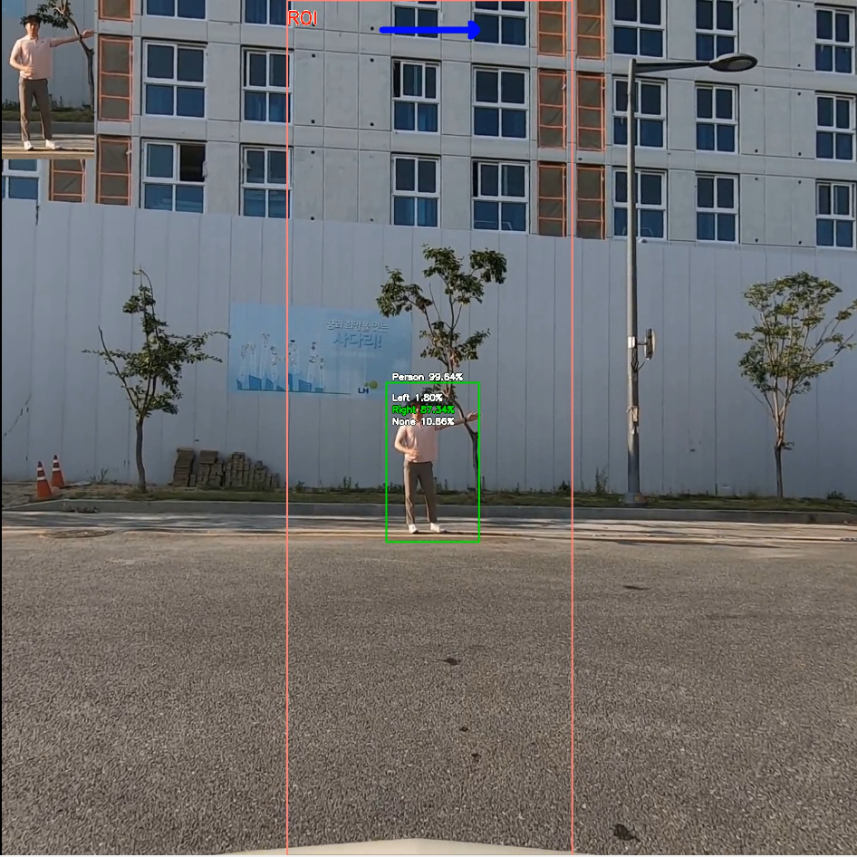

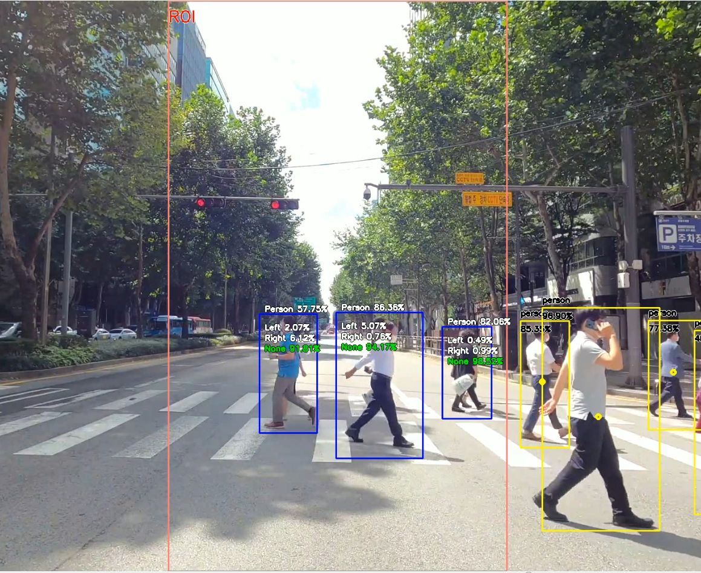

**Exercise application using Pose estimation AI** July.2020~Sep.2020

Research Intern Manager : Dr. Dohyung Kim

Electronics and Telecommunications Research (ETRI))

* Produced Android application using Pose Estimation, Pose similarity AI
* Indicated pose similarity to the lower right pose with color line
* Using Kotlin, NDK

Task name : Development of Human-care Robot Technology for Aging Society

NTIS task number : 1711103145

**3D Skeleton Editor** Mar.2019~July.2019

Contract developer

Electronics and Telecommunications Research (ETRI)

* Expressed video from Kinect using OpenGL and can modify wrong joint position in 3D.
* Produced with C++ MFC, Open GL

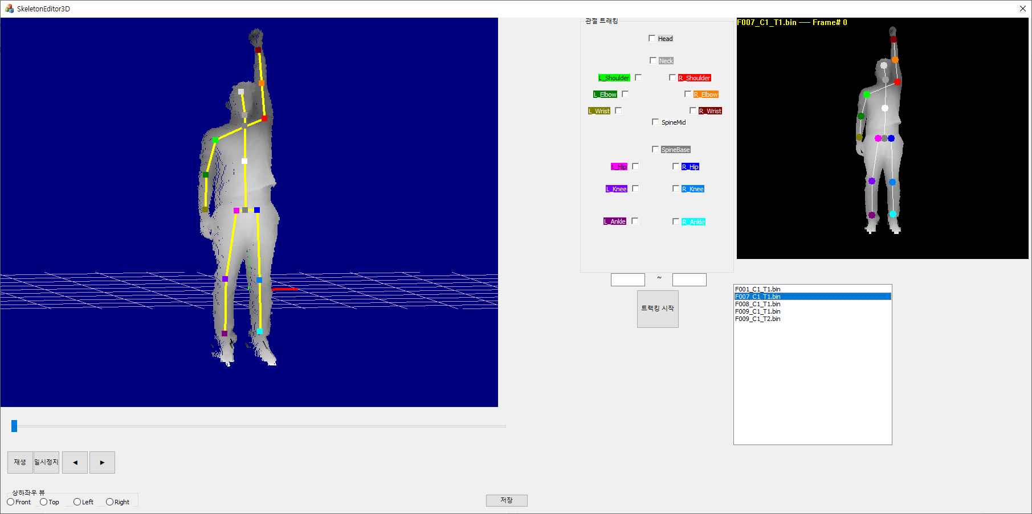

Additional Information

English skills

TOEIC : 770

Communication : Intermediate (Worked in New Zealand as a Working holiday) July.2019 ~ June.2020

Laboratory Experience

Syslet Database Laboratory, N5-502, Daejeon, Hanbat National University.

(Advisor : Prof. Youngchan Kim)

Lab Researcher Sep.2017 ~ Present

Lab Captain Mar.2018 ~ Dec.2018

Military service

Complete Military service as an Auxiliary Police man, Korean National Police Agency Oct.2015 ~ July.2017

Reference

On request.